**Connecting to RTS Clusters (Macintosh version)**

2019-10-16  
jakelly@chapman.edu

version .03

# Introduction

This document covers:

1. Connecting and authenticating to Chapman RTS clusters in text/shell mode (SSH) from Macintosh computers.
2. Connecting and authenticating to Chapman RTS clusters in graphical/GUI mode (X2Go) from Macintosh computers.

# Network Connectivity Notes:

On campus, you will need to be connected through a physical ethernet cable or EduRoam wireless. Depending on your location on campus, you may also need to be connected through the campus VPN server, vpn.chapman.edu.

Off campus, or on-campus but connected to ChapmanOpen wireless, you will always need to connected through the campus VPN server.

# Connecting to RTS Clusters Using SSH on Macintosh

An SSH client provides network-optimized, cryptographically-secure text-mode access to remote hosts and devices running SSH server software. All SSH communication is securely encrypted. No credentials, commands, or data are ever communicated in plaintext.

On a Macintosh, Chapman RTS recommends using the xterm terminal built into [XQuartz](https://www.xquartz.org/) as your SSH client.

Other free clients that work (with some limitations) are [Putty](https://www.chiark.greenend.org.uk/~sgtatham/putty/) and the MacOS [terminal.app](https://support.apple.com/guide/terminal/welcome/mac) (which is different than the [XQuartz](https://www.xquartz.org/) xterm terminal).   
RTS recommends [XQuartz](https://www.xquartz.org/) and its included xterm terminal because:

* [XQuartz](https://www.xquartz.org/) includes built-in graphical display redirection, which displays graphical applications started on a remote server as though they were run locally
* They were originally built by Apple (who later donated it into the public domain, as an open-source project under the [X.org Foundation](https://www.x.org))
* [XQuartz](https://www.xquartz.org/) the official X Server application for Macintosh OS/X
* They are free and open-source

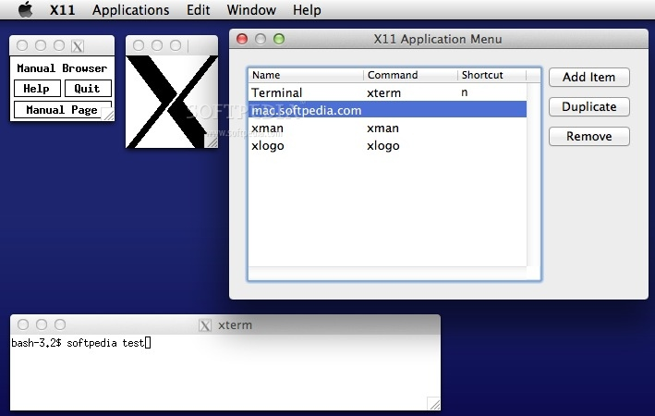  
XQuartz X11 Server application for Macintosh OS/X, with accessory and xterm terminal windows open. Graphic credit www.softpedia.com.

## Configuring XQuartz for connections to an RTS cluster:

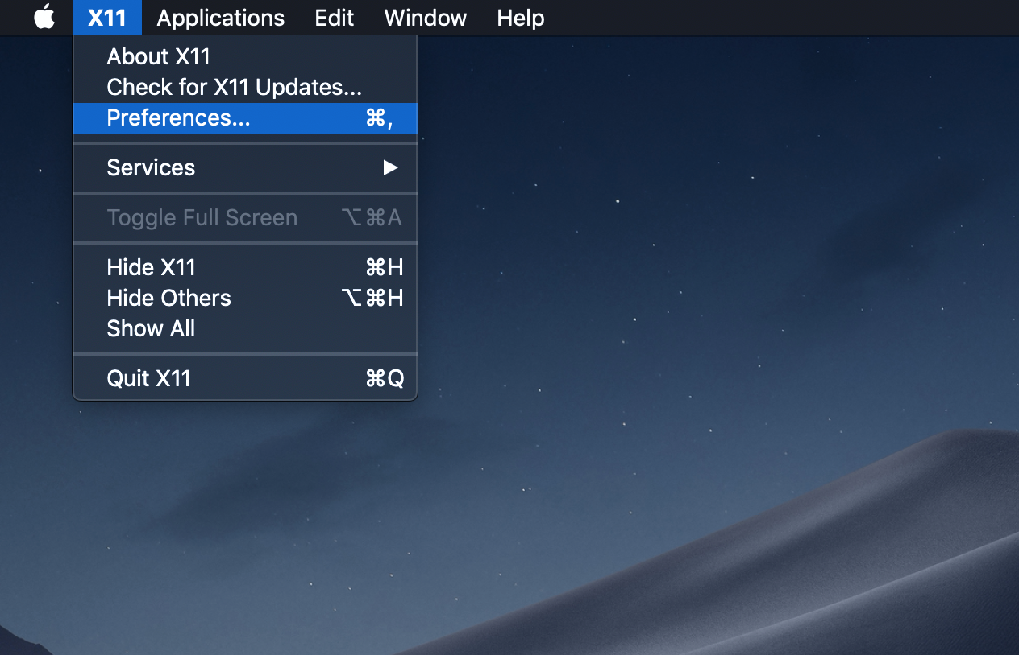  
XQuartz X11 menu, with Preferences selected

XQuartz needs a few custom settings for compatibility with RTS cluster access.

Start XQuartz. Open the X11 menu and select Preferences.

When the X11 Preferences dialog opens, click the Input tab. Check all checkboxes.

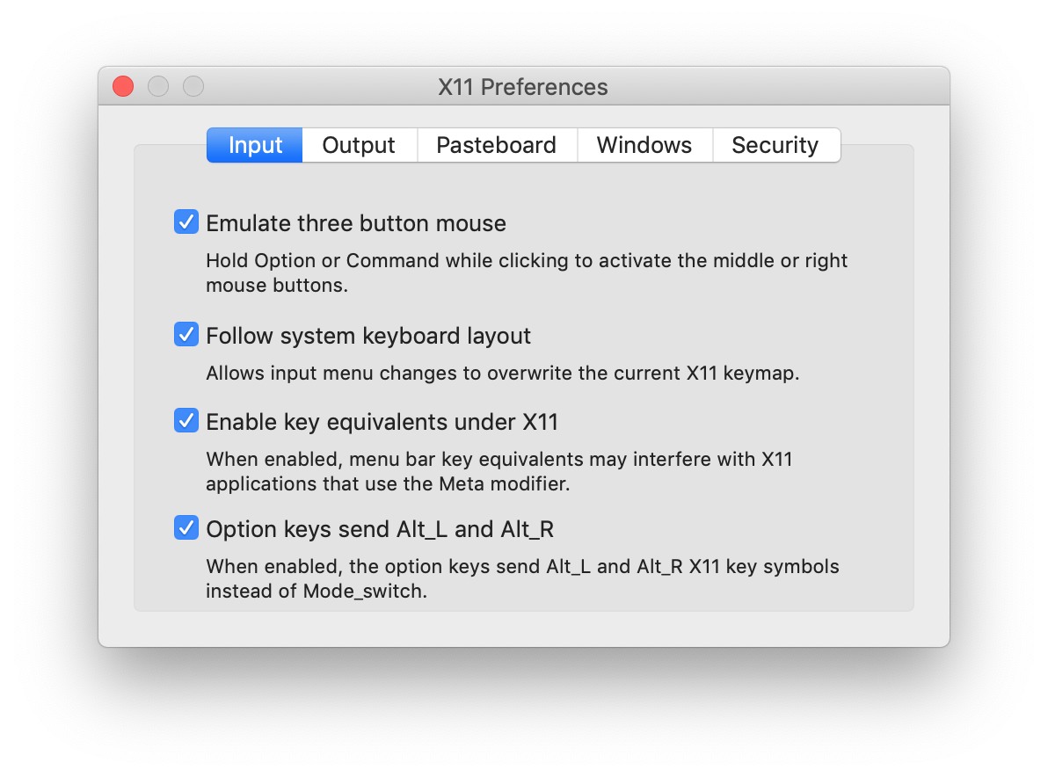  
XQuartz X11 Preferences, Input tab selected

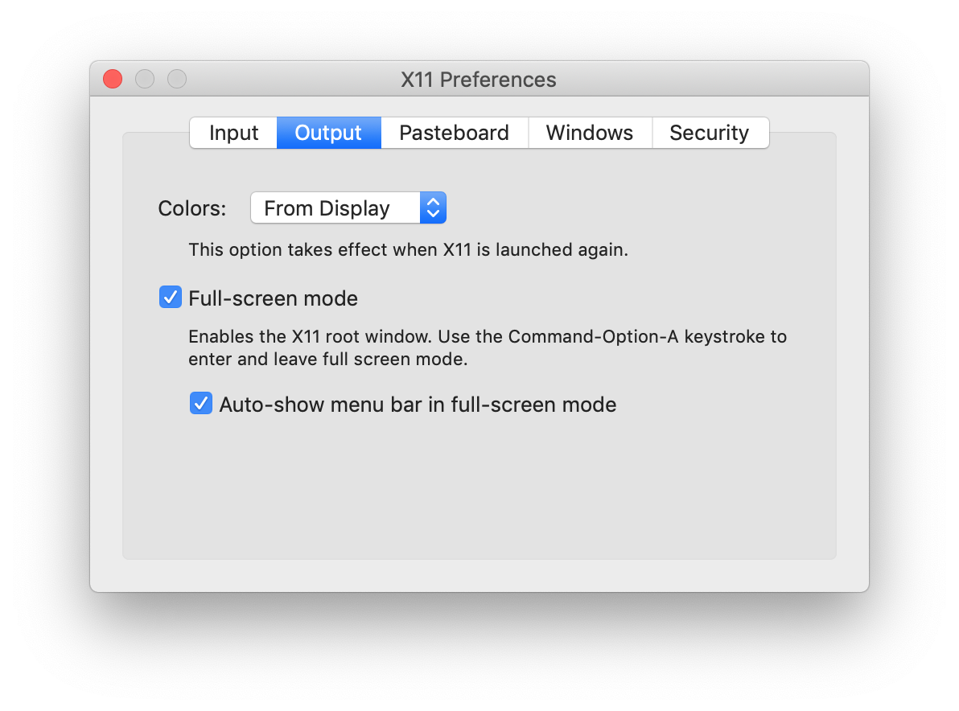  
XQuartz X11 Preferences, Output tab selected

Click the Output tab. Check all checkboxes here also.

## Configuring XQuartz for connections to an RTS cluster (continued):

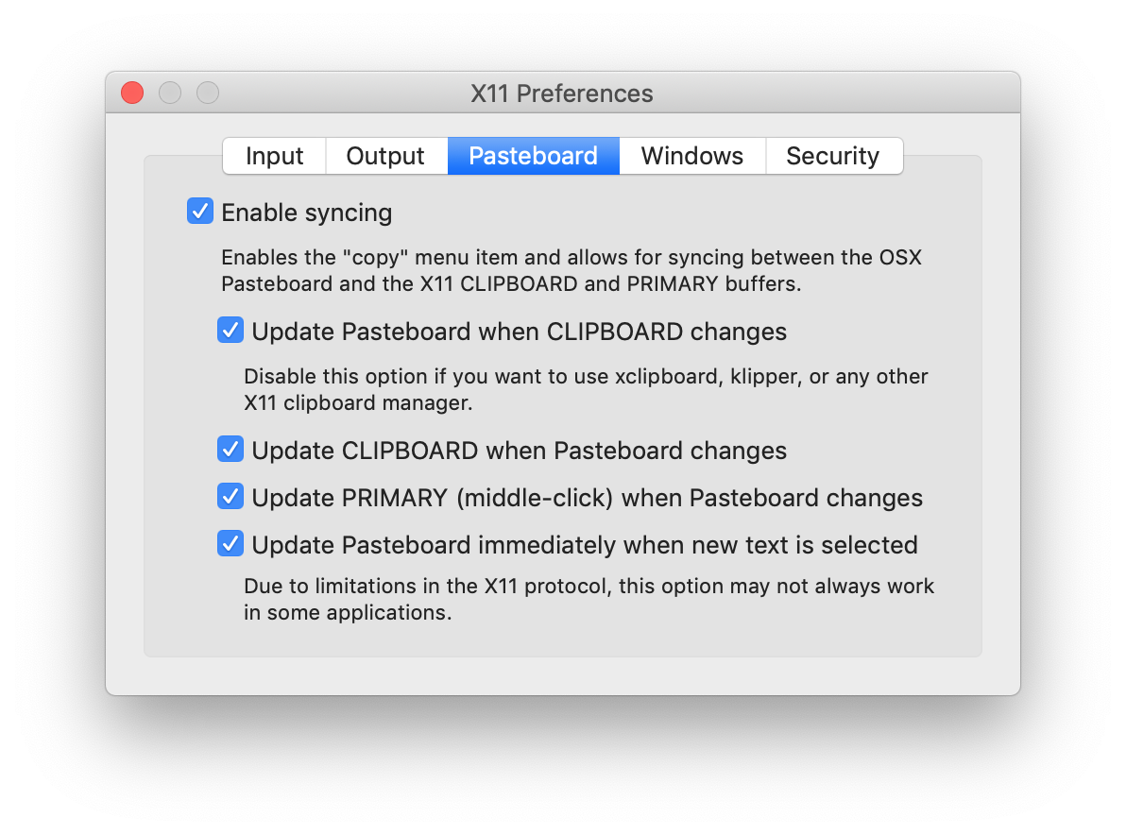  
XQuartz X11 Preferences, Pasteboard tab selected

Click the Pasteboard tab. Check all checkboxes.

(If you later notice that cut-and-paste actions don’t work as expected,

unchecking the last checkbox on this tab, “Update Pasteboard immediately

when new text is selected”, might help fix some issues.)

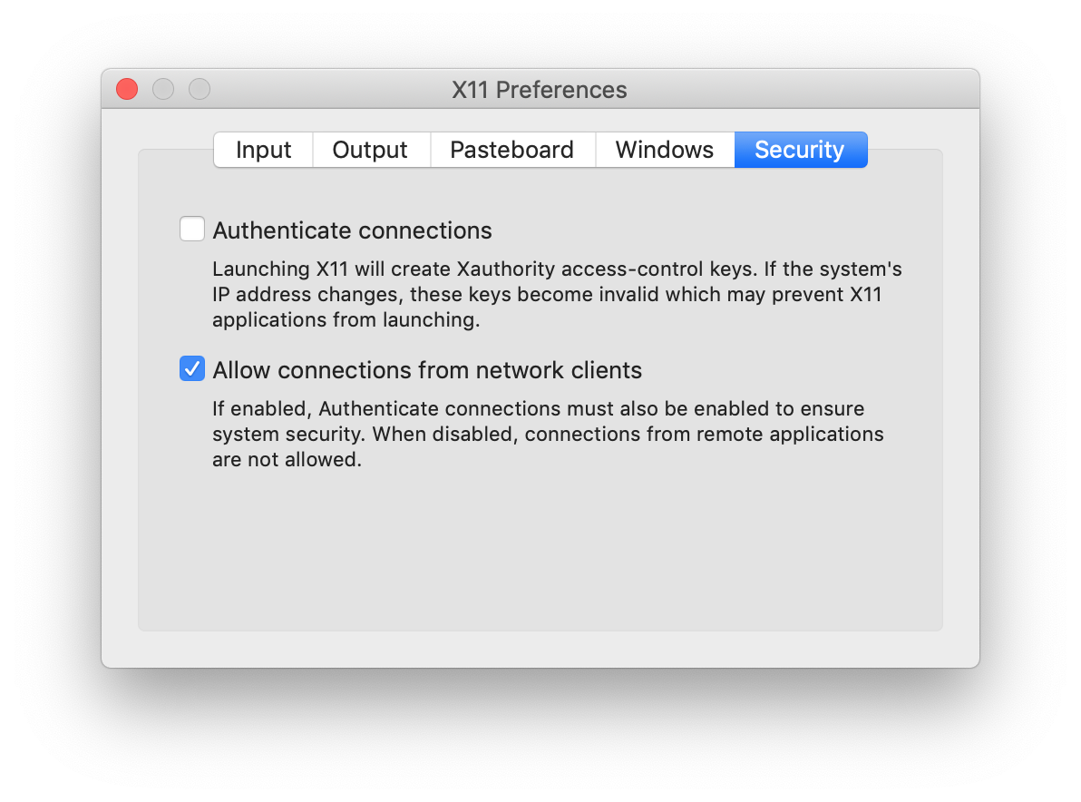  
XQuartz X11 Preferences, Security tab selected

Finally, on the Security tab:

uncheck “Authenticate connections”,

check “Allow connections from network clients”.

Close the X11 Preferences dialog window to save the changes.  
Close and re-open XQuartz to make the changes take effect.

## Connecting to an RTS cluster using SSH:

Start XQuartz. Once the local ssh client is running, use the command ssh -Y {username}@chapman.edu@{hostname}.chapman.edu to connect to the server.

bash-3.2$ ssh -Y {username}@chapman.edu@{hostname}.chapman.edu

All Chapman RTS clusters are integrated into the campus **single-sign-on** environment. Your login name will be your **full Chapman email address**, including @chapman.edu or @mail.chapman.edu. Your password will be your email password.

*[Don’t include the curly braces. In this document curly braces identify variables to be replaced in input.]*

Replace {username}@chapman.edu with your login name (your full Chapman email address), and {hostname}.chapman.edu with the DNS name for the cluster login node. For the Keck cluster, use keckcluster.chapman.edu.

bash-3.2$ ssh -Y tysmith@chapman.edu@keckcluster.chapman.edu

Accept any ssh warnings by entering yes or y, then enter your password for the server. For security reasons, the password will not be visible as you enter it. The -Y parameter tells the server to enable graphical display redirection.

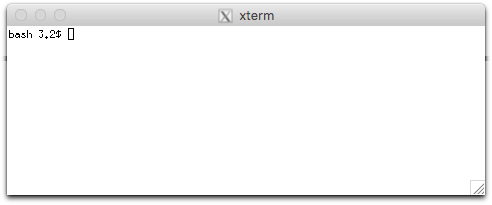  
XQuartz xterm terminal window

## Running programs through SSH on the server:

Once connected, any text-mode (“shell” or “terminal”) programs you run will show their output in the terminal window. You can connect as many terminal tabs or windows concurrently as you need. When your processes are all finished, use the command exit to disconnect, or just close the terminal window.

Closing the SSH client application without exiting first will disconnect all logged-in terminal windows, abruptly terminating any running programs. (Both shell and graphical programs.) The failure of a network connection or VPN tunnel will also terminate all sessions. Server-side “connection manager” utilities (like [tmux](https://www.hamvocke.com/blog/a-quick-and-easy-guide-to-tmux/), [screen](https://linuxize.com/post/how-to-use-linux-screen/), or [byobu](http://byobu.co/)) can be used to keep sessions open across disconnections, avoiding lost work and corrupted data.

If you are running a local X server application (like [XQuartz](https://www.xquartz.org/)), the windows of any graphical programs you start on the server (firefox, jupyter, RStudio, etc.) from your terminal window will be redirected back to your local computer. They will look very much like they are running locally, except for some slowness caused by network lag. Any file locations shown in their dialogs will refer to storage locations on the server.

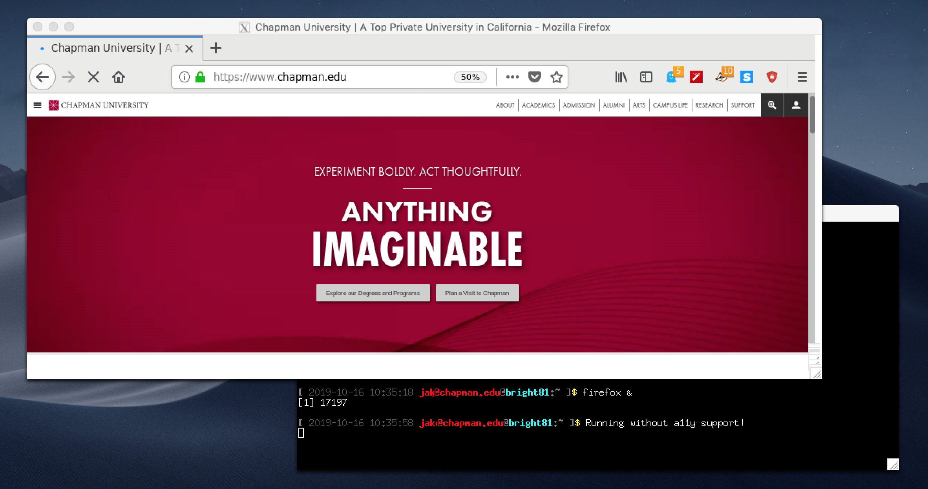  
A logged-on SSH session, with a remote firefox window displayed locally though graphical display redirection

# Connecting to RTS Clusters Using X2Go

Unlike an SSH client, which uses a terminal window to run remote applications, redirecting applications separately back to your local display, the X2Go graphical remote-access client relays the entire desktop, including menus, icons, toolbars, and background.

The main advantage of X2Go is responsiveness. Redirecting the entire remote display results in much faster graphical access to the remote server, tunable for different speeds of network connection.

Some users also like having fewer windows to manage, or like having all work associated with a particular server or project organized into a single window.

The download link and installation instructions for the X2Go client are available [here](https://wiki.x2go.org/doku.php/doc:installation:x2goclient).   
Once installed, running the client displays the main connections window:

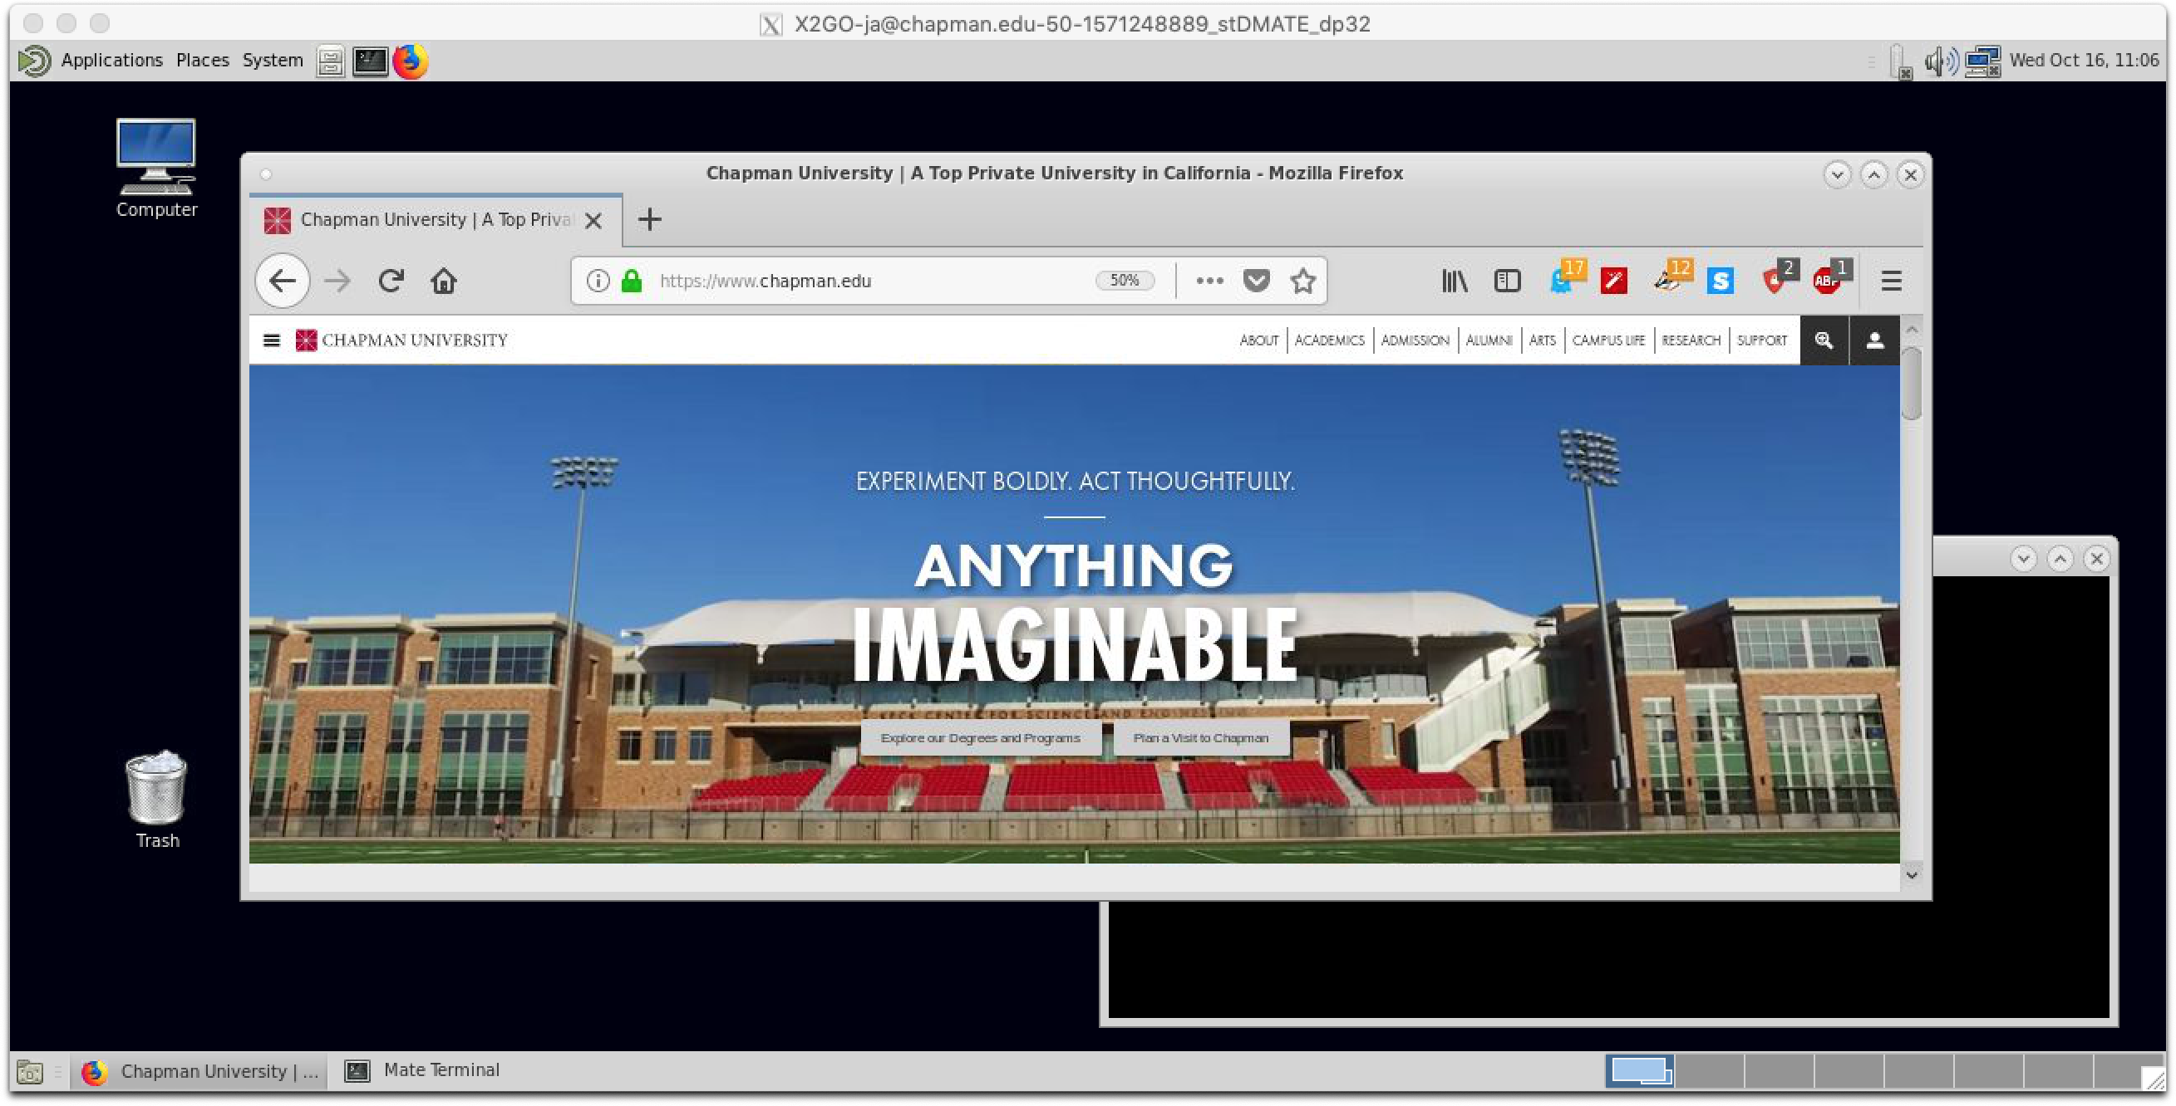  
X2Go remote graphical client window, showing the full keckcluster.chapman.edu [MATE](https://mate-desktop.org/) desktop

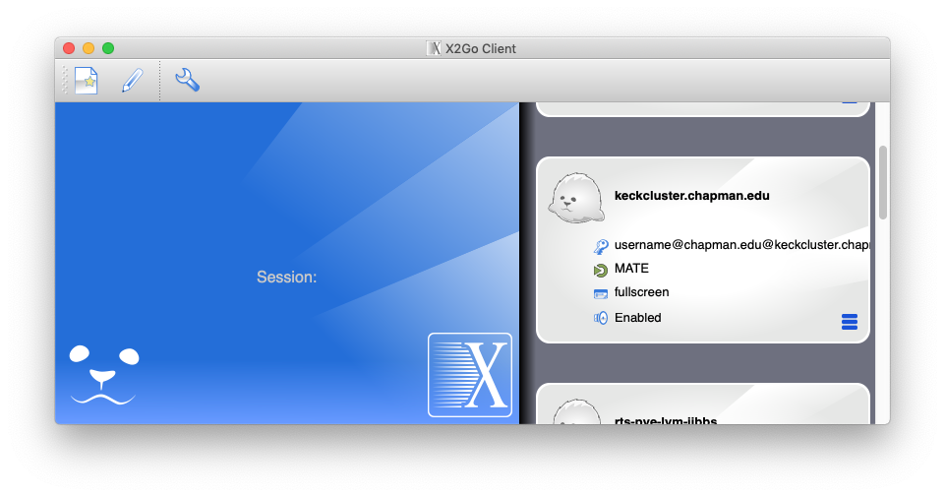  
X2Go Client main window, showing a Saved Session entry for keckcluster.chapman.edu

The first task is to create a new Saved Session entry for keckcluster.chapman.edu.

## Create a new Saved Session entry:

To create a new Saved Session entry, either click the New Session button, or use the menu items, Session --> New Session.

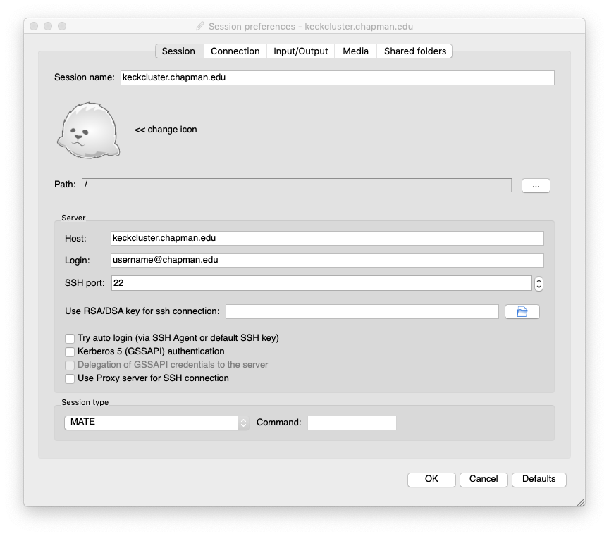  
X2Go client, Session Preferences dialog, Session tab, for a new Saved Session entry.

On the Session tab, set:

Session name: to a name for the saved session.

Host: to the DNS name or IP address of the cluster login node you want to connect to. For the Keck cluster, use keckcluster.chapman.edu.

Login: to your full Chapman email address, including @chapman.edu or @mail.chapman.edu.

Session type: to MATE.

(Later, when you open these settings again, the drop-down menu will say Custom desktop and MATE will appear in the Command: text-box. You do not need to do anything. That is normal.)

X2Go will not save your password. You will need to enter your password each time you log in.

Feel free to click the “<< change icon” button. Most types of graphical file can be used as a Saved Session icon.

Then click the Input/Output tab.

## Create a new Saved Session entry (continued):

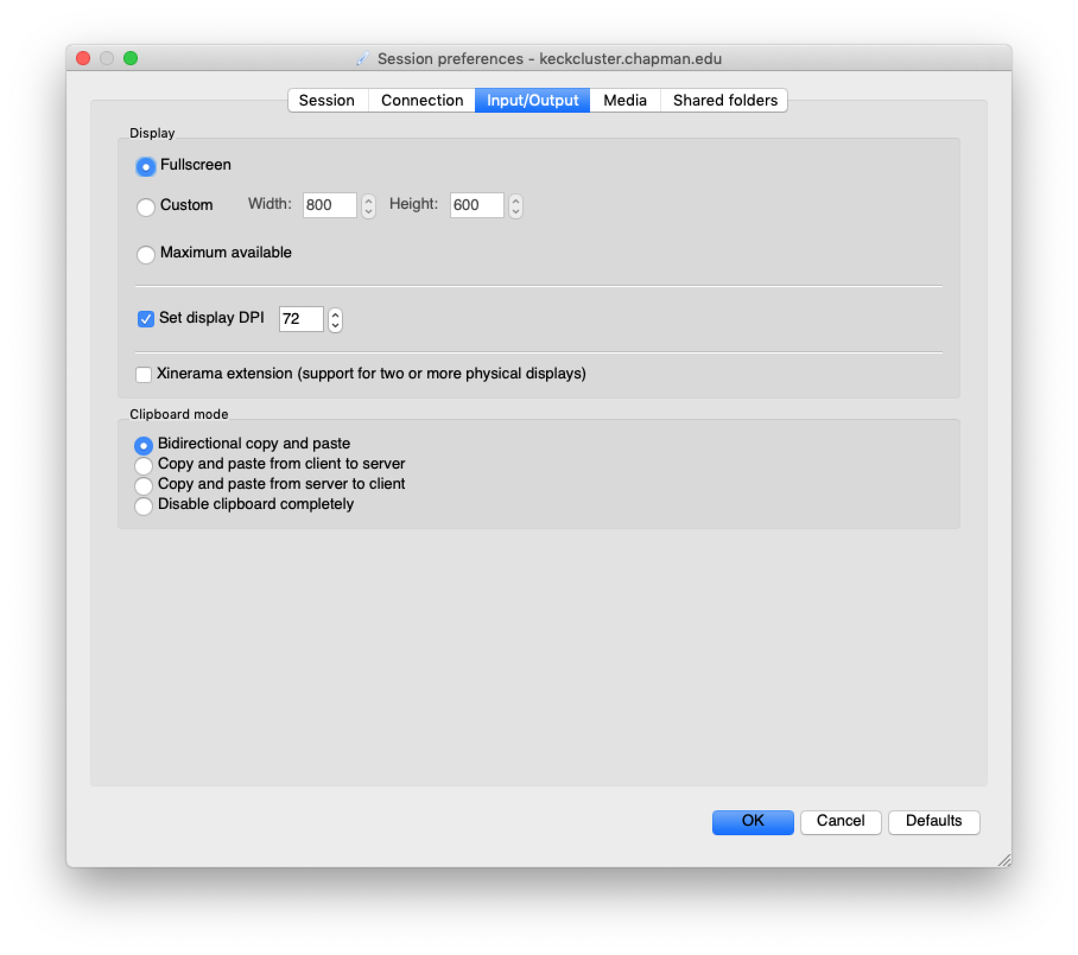  
X2Go client, Session Preferences dialog, Input/Output tab, for a new Saved Session entry.

On the Input/Output tab, set:

Display: to Fullscreen. (Fullscreen is simplest to start with. Please feel free to experiment with the other choices later to find what works best for you.)

Set display DPI: Leave this at its current value, for now.

After you successfully log in once, experiment with this setting. The higher you set it, the smaller it makes the graphical elements on the remote server appear. This adjustment can be very useful when working from very small or very large local screens.

Then click the Shared folders tab.

## Create a new Saved Session entry (continued):

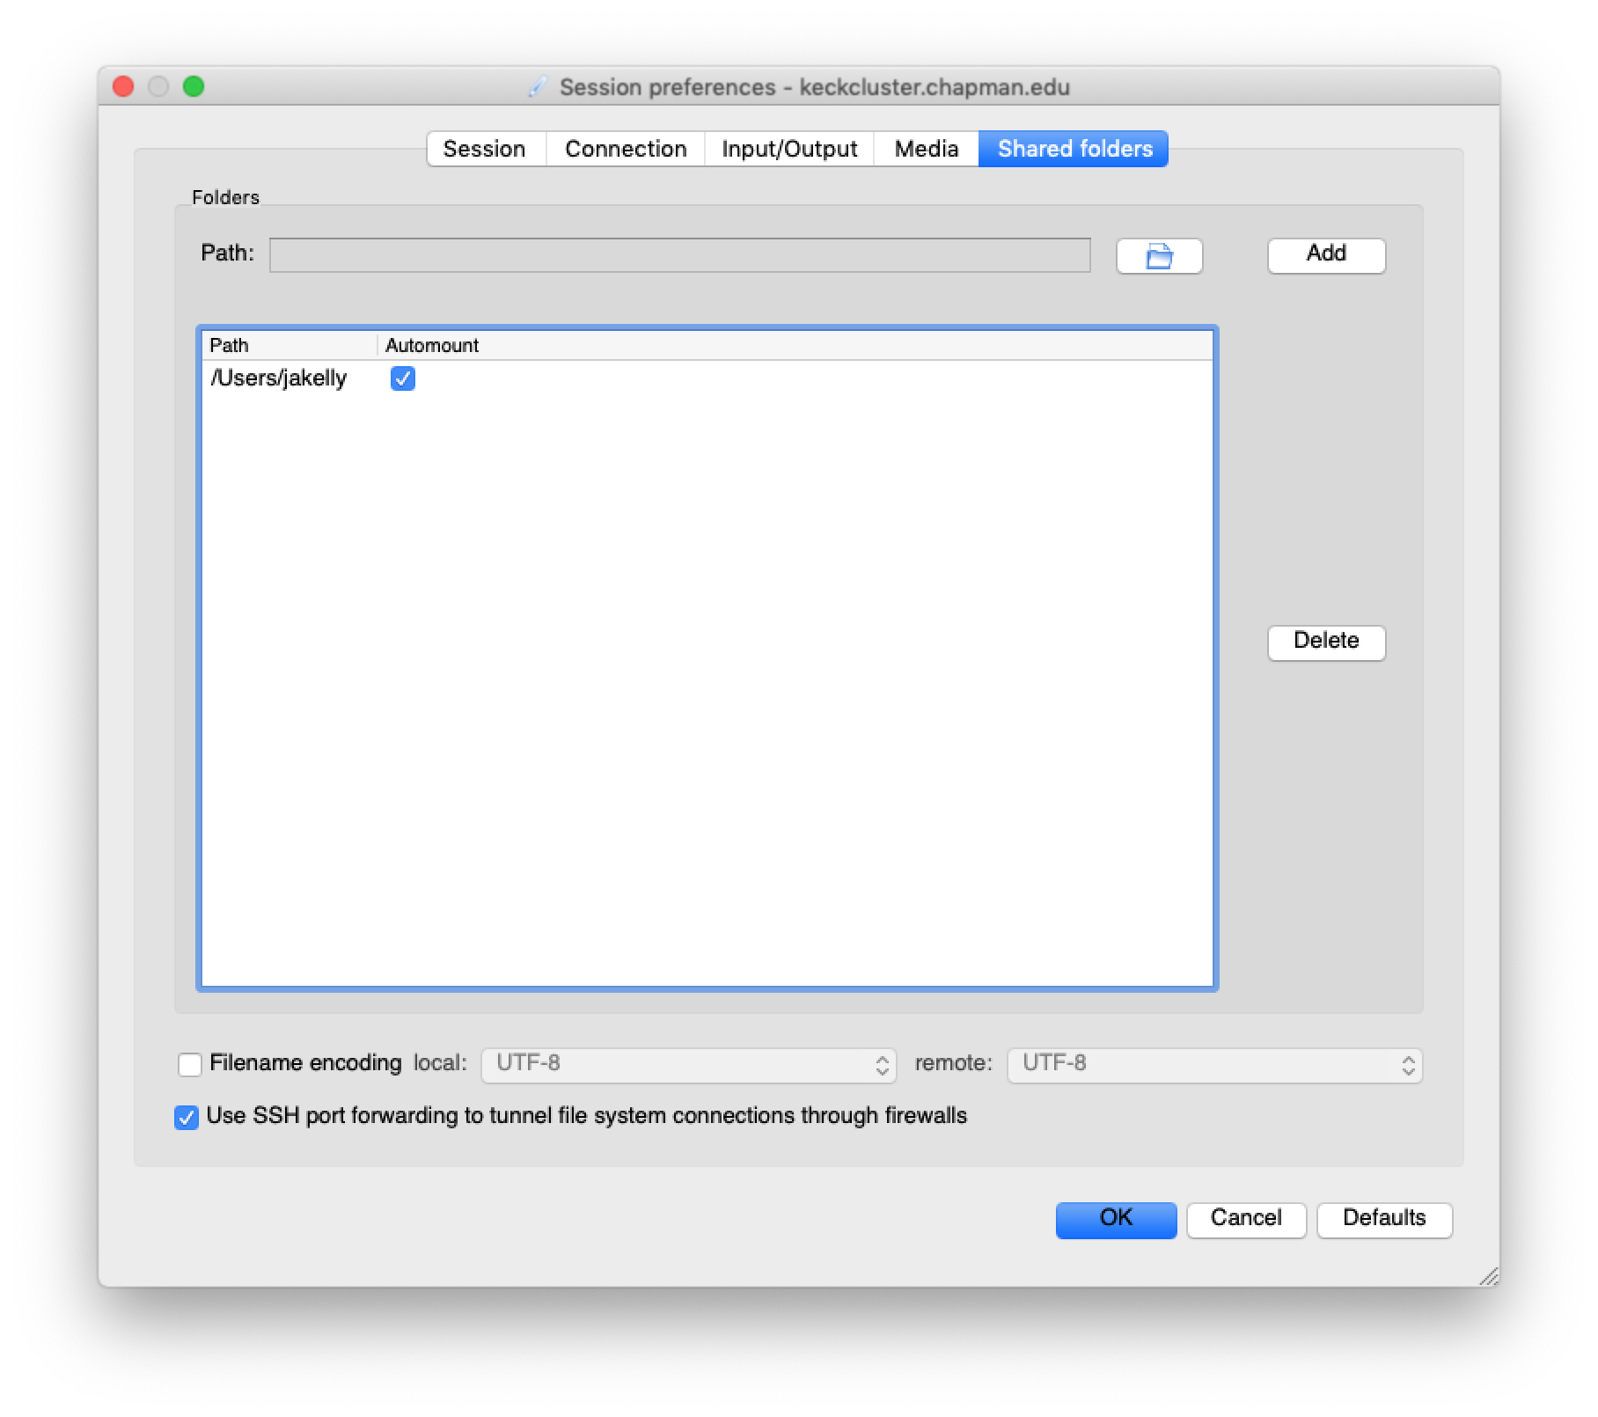  
X2Go client, Session Preferences dialog, Shared folders tab, for a new Saved Session entry.

On the Shared folders tab, set:

Path: Set this to a local computer storage path that you want to be connected on the remote server. You can also click the small 🖿 Browse button next to the text-box to select the folder you want mounted.

Once you have entered or selected a folder, click the Add button to make the folder appear in the Path column of the Folders list.

Check the Automount check-box to have it mounted automatically when you log in.

You can add as many local folders as you would like.

When you log in, a virtual alias to the local folders will be mounted in your cluster home-directory at the path:

{REMOTE_HOMEDIRECTORY}/media/disk/{foldername}

Then click the OK button to save the new Saved Session entry.

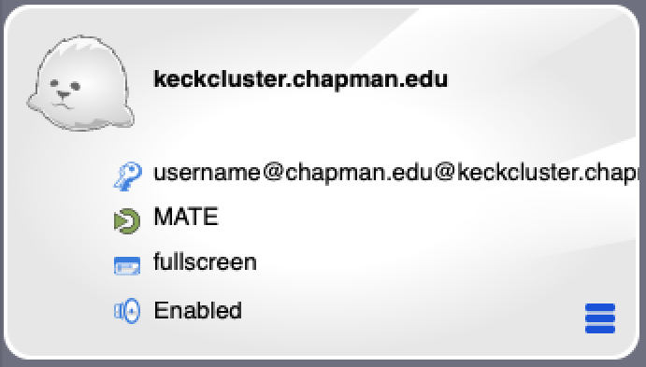

The new Saved Session entry will appear in the list in the main X2Go window.

## Connect to the RTS cluster using X2Go:

Double-click the new Saved Session entry to start the connection process. A login window will appear in the middle of the X2Go main window:

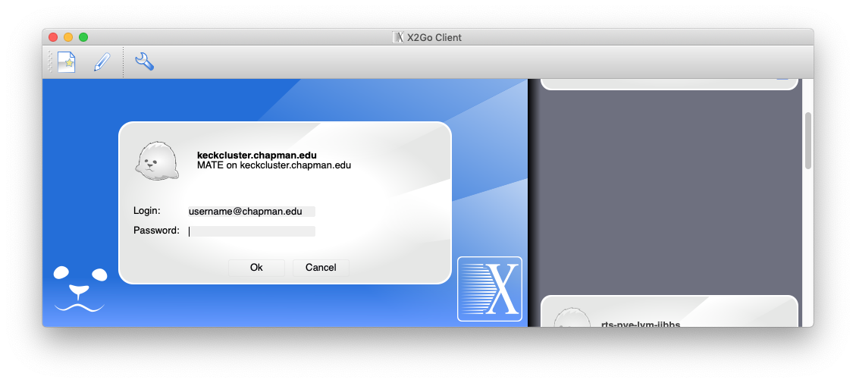  
X2Go client main window showing logon credentials dialog.

Enter your Chapman single-sign-on (email) password. Click the Ok button to connect.

## Using the remote desktop of the RTS cluster login node:

If the X2Go client connects and logs in successfully, the cluster login node’s desktop will appear, in a single local window.

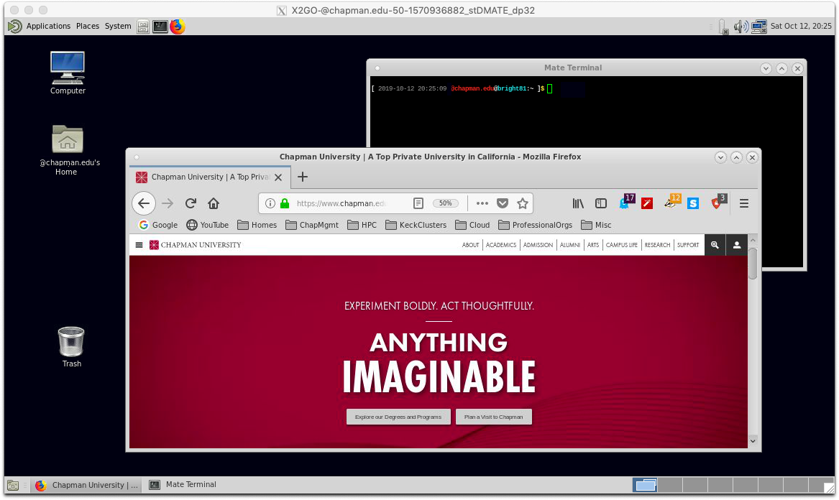  
X2Go remote graphical client window, showing the full keckcluster.chapman.edu [MATE](https://mate-desktop.org/) desktop

The Linux MATE desktop is similar to Macintosh and Windows desktops. The design will be familiar for a majority of users.

One primary difference is that most research applications are started using the terminal window, rather than menu items.

## Repairing Failed Keyboard Settings for the X2Go Client remote desktop:

The current version of the X2Go client often fails to detect the keyboard correctly for Macintosh users. When this happens, the arrow keys on the remote desktop fail to work, and the keyboard is scrambled when typing text, producing gibberish.

This is the process to repair the failed keyboard settings.

  
XQuartz X11 Preferences, Input tab selected

Verify Local XQuartz Input settings

Before you connect to the remote server, first verify that XQuartz has the correct local settings to work correctly with the remote desktop.

In the local Macintosh’s XQuartz preferences, make sure that all checkboxes are checked on the Input tab.

Restart XQuartz if you haven’t yet, to make sure that these settings have taken effect.

Open the Keyboard settings on the remote server

Once the X2Go client is successfully connected and logged in,  
open the remote server’s System menu. Select Hardware , then Keyboard .

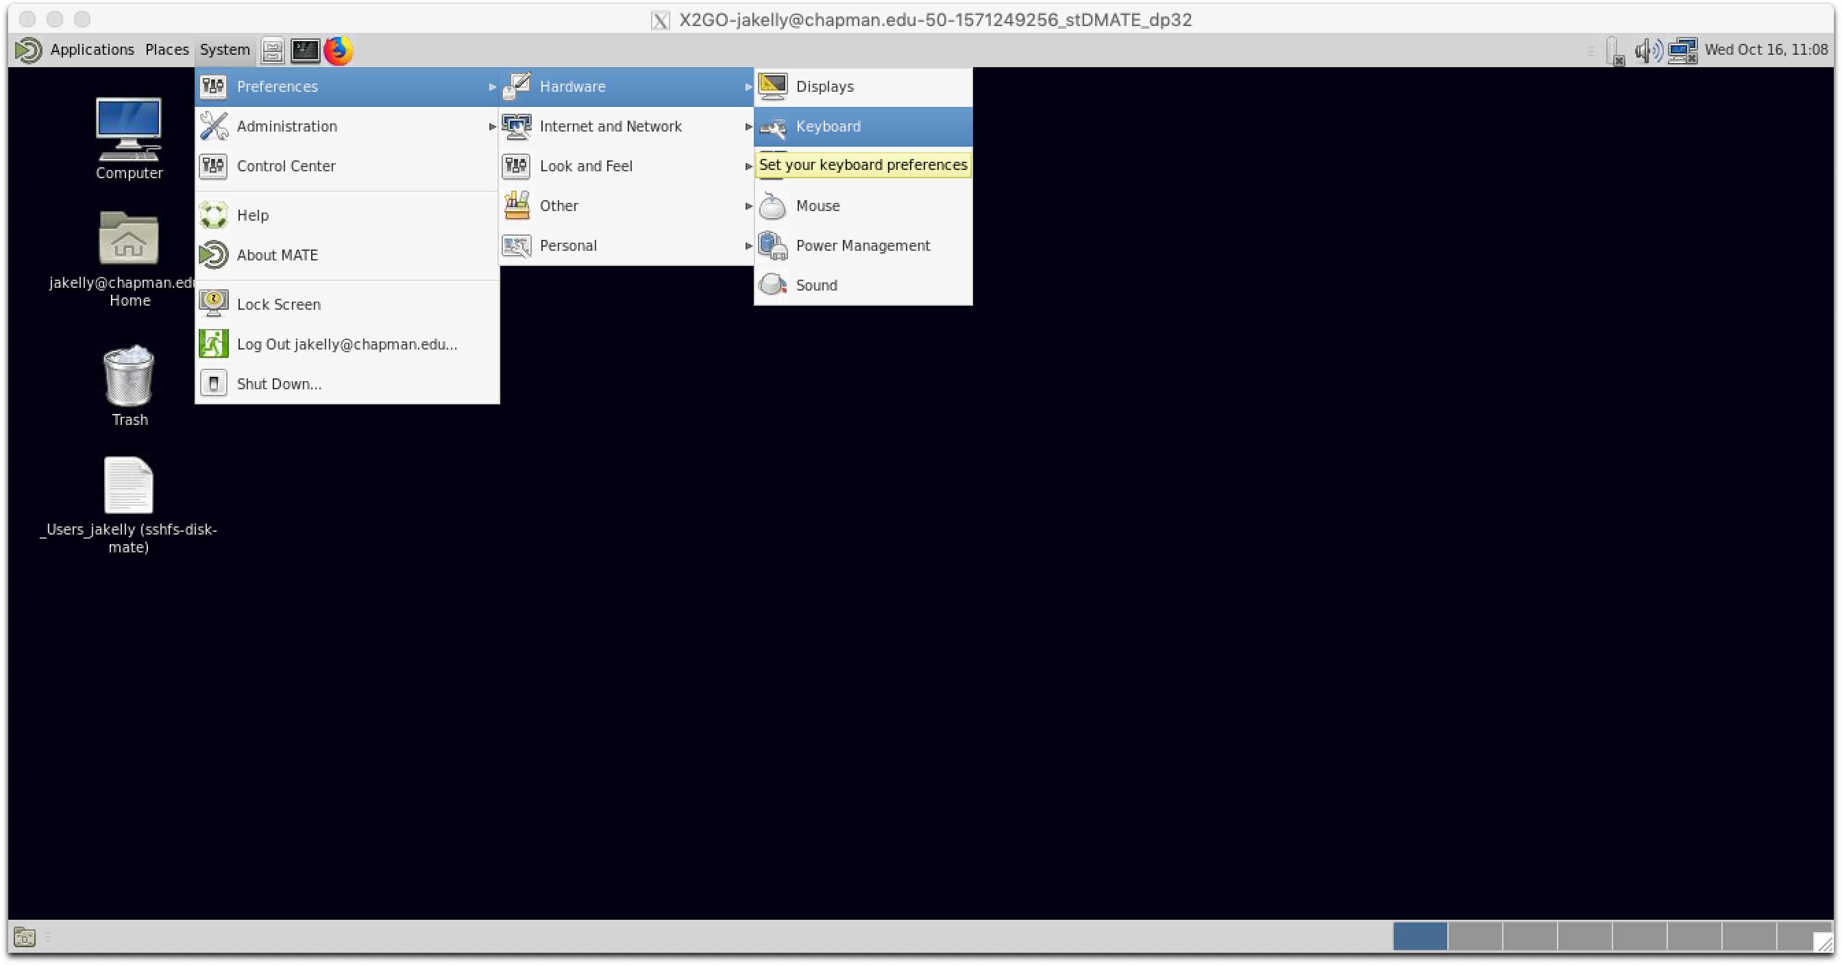  
Linux MATE desktop, System menu, Preferences, Hardware, Keyboard settings menu item selected

## Configuring Keyboard Input Settings (continued):

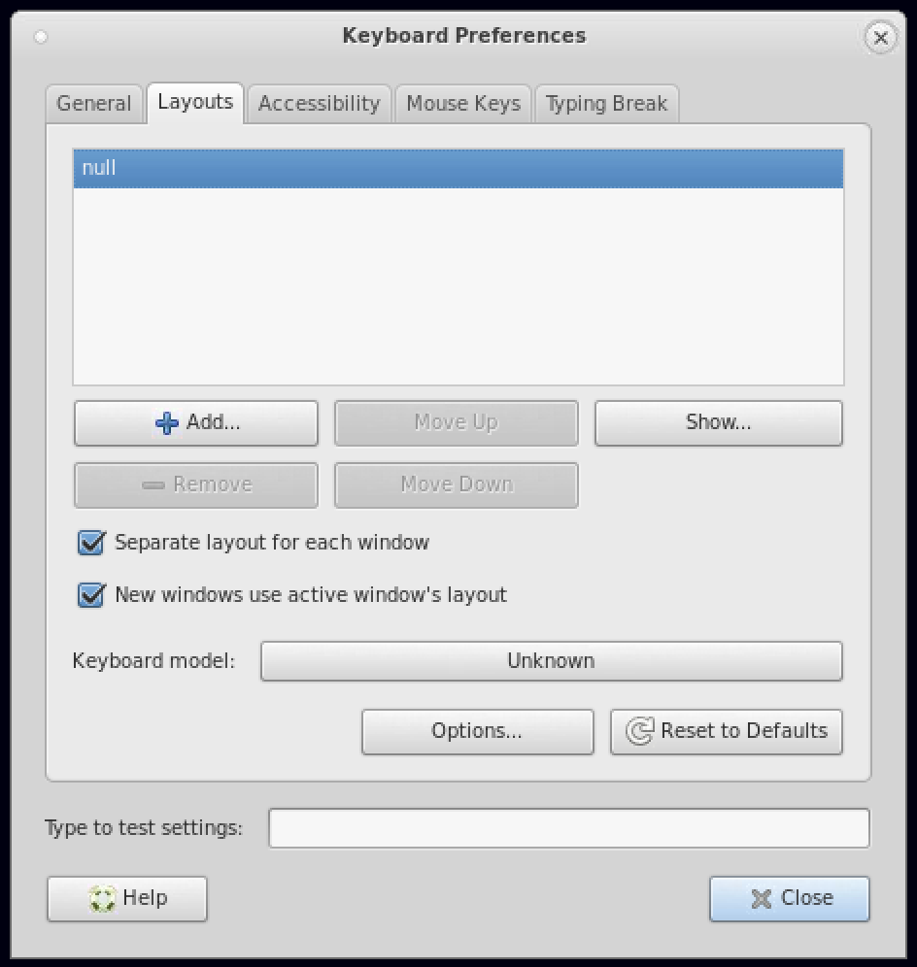  
Linux MATE desktop, Keyboard preferences dialog, Layouts tab selected

Replace the failed keyboard layout

In the Layouts tab, the misconfigured layout will be listed as null.

Click the **+** Add… button. The Choose a Layout dialog opens.

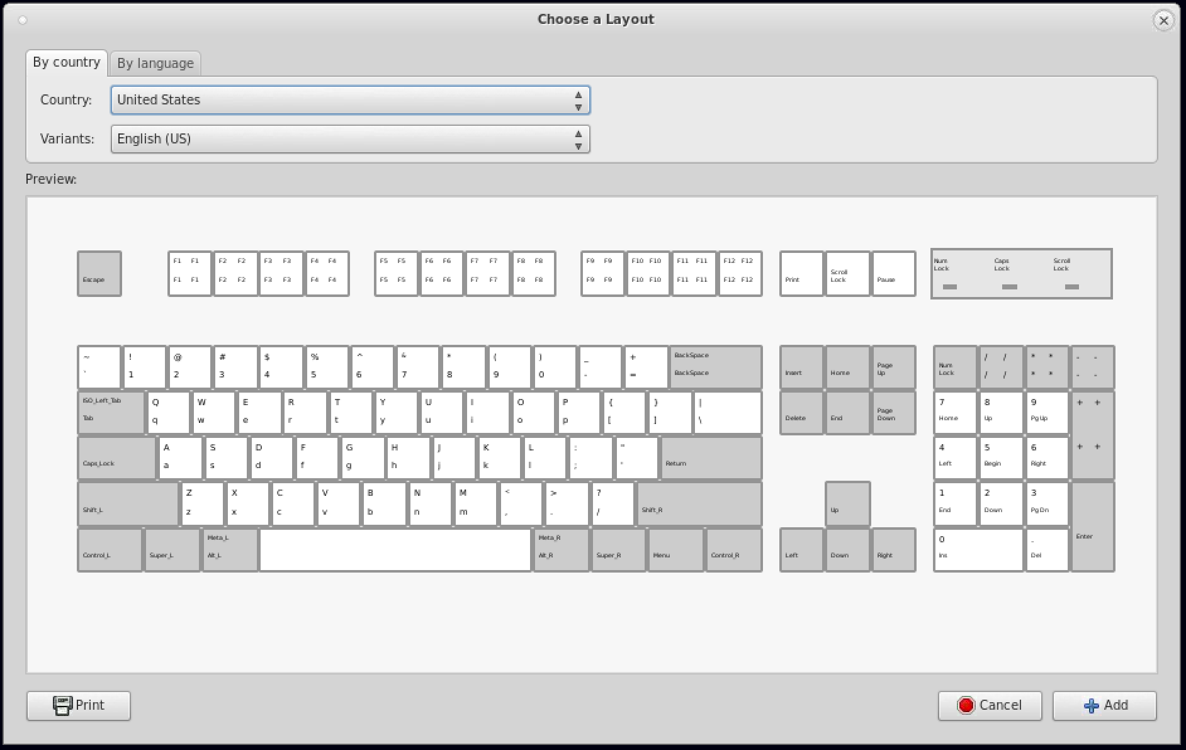  
Linux MATE desktop, Keyboard preferences, Choose a Layout window

In the Choose a Layout window,

Country: select “United States”  
Variants: select “English (US)”.

Then click the **+** Add… button to add (save) the new layout.

## Configuring Keyboard Input Settings (continued):

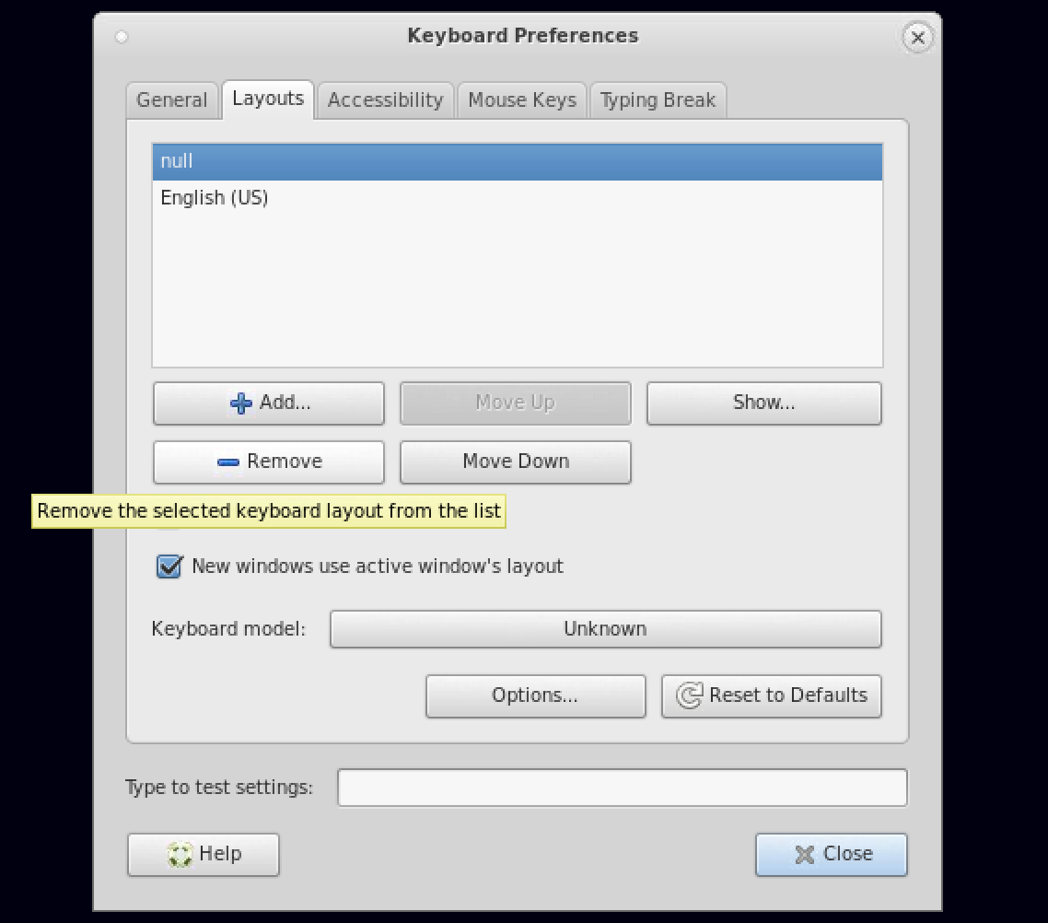  
Linux MATE desktop, Keyboard preferences dialog

Remove the failed keyboard layout

Back in the **Keyboard Preferences** window, highlight (click) the broken null layout.

Click the **−** Remove button to delete the null layout.

Set the keyboard model for the replacement layout

Highlight (click) the new English (US) keyboard layout.

Click the Unknown button to set the correct Keyboard model: for the new layout.

The **Choose a Keyboard Model** dialog window opens.

In the **Choose a Keyboard Model** dialog,

Vendors: select “Generic”

Models: select “Generic 105-key PC (Intl.)”

Click the **⮰** OK button to accept the settings.

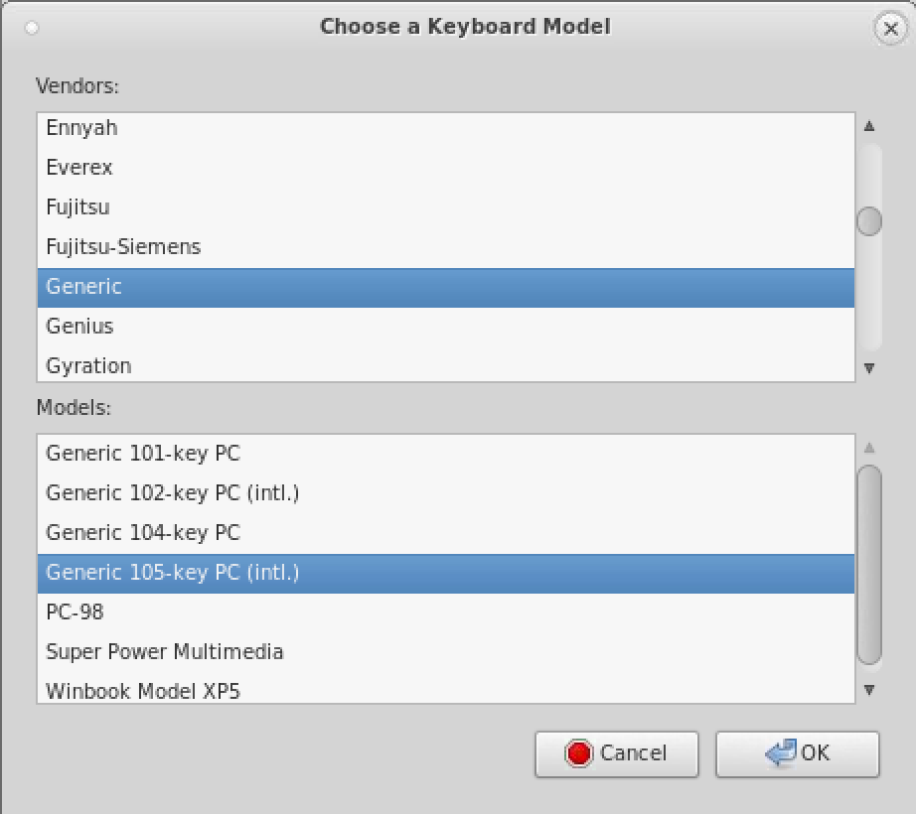  
Linux MATE desktop, Keyboard layout settings, Choose a Keyboard Model dialog

## Configuring Keyboard Input Settings (continued):

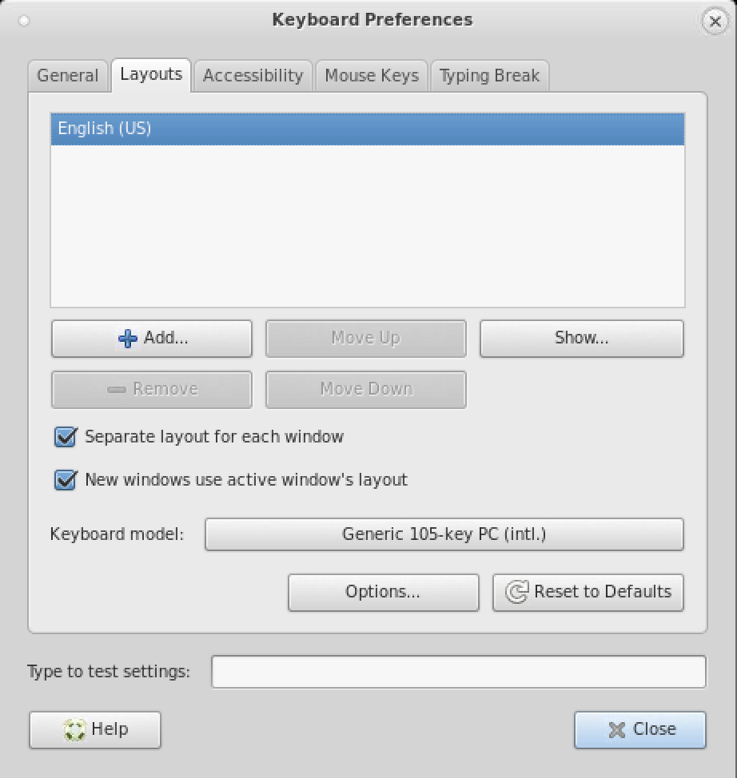  
Linux MATE desktop, Keyboard preferences dialog, Layouts tab

Back in the **Keyboard Preferences** dialog, verify that there is only one layout, English (US), and that the Keyboard model: is set to Generic 105-key PC (Intl.).

Click the 🞬 Close button to save the changes.

The changes will take effect immediately.

The repaired settings are saved for future sessions.

## Ending a remote desktop session:

To exit the remote desktop session, in the menus, select System --> Log Out {username}@chapman.edu.

The remote desktop session will close and you will be logged out of the remote server. Any running processes will be terminated, unless protected by a session manager utility.

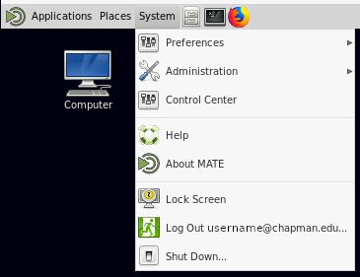  
The System menu of a remote Linux MATE desktop.